**1. What does an empty dictionary's code look like?**

Ans.) An empty dictionary's code look like two curly brackets: {}

**2. What is the value of a dictionary value with the key 'foo' and the value 42?**

Ans.) 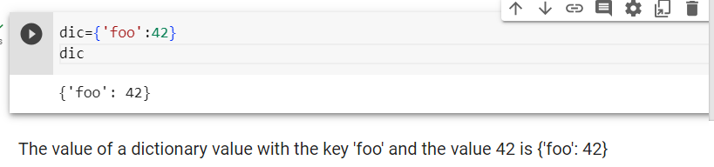

**3. What is the most significant distinction between a dictionary and a list?**

Ans.)

|  |  |
| --- | --- |
| **Dictionary** | **List** |
| A dictionary is an unordered collection of key-value pairs, where each key is unique and used to access its corresponding value. | A list is an ordered collection of elements that are accessed using numerical indices (starting from 0). |
| In a dictionary, elements are accessed by their keys, such as my_dict['key'], which retrieves the value associated with the key. | In a list, elements are accessed by their index, such as my_list[0], which retrieves the first element. |
| Dictionary keys are immutable (typically strings or numbers), but the corresponding values can be mutable. You can add, modify, or remove key-value pairs within a dictionary. | Lists are mutable, allowing you to modify, add, remove, or reorder elements directly within the list. |
| Dictionaries are suitable when you need to store and retrieve data based on specific keys, often used for mapping or associating values with unique identifiers. | Lists are commonly used when you have a collection of items that need to be accessed in a specific order, and the order might change or elements might be repeated. |

**4. What happens if you try to access spam['foo'] if spam is {'bar': 100}?**

**5. If a dictionary is stored in spam, what is the difference between the expressions 'cat' in spam and 'cat' in spam.keys()?**

**6. If a dictionary is stored in spam, what is the difference between the expressions 'cat' in spam and 'cat' in spam.values()?**

**'cat' in spam** checks whether there is a 'cat' key in the dictionary, while **'cat' in spam.values()** checks whether there is a value 'cat' for one of the keys in spam.

**7. What is a shortcut for the following code?**

**if 'color' not in spam:**

**spam['color'] = 'black'**

Ans.) Shortcut for above code is:

spam.setdefault('color', 'black')

**8. How do you "pretty print" dictionary values using which module and function?**

Ans.) To "pretty print" dictionary values in Python, you can use the pprint module and its pprint() function. The pprint module provides a way to format and print complex data structures, such as dictionaries, in a more readable and organized manner.

